**Salesforce Supported SmartInternz Virtual Internship Program Cohort-3-Salesforce Developer 23 Aug to 20 Oct 2023**

**Document for Additional Guided Project**

**“Retail Management Application Using Salesforce”**

**Submitted By**

**Name: Sandhya Balasaheb Jadhav**

**Email:** [**sandhyajad202@gmail.com**](mailto:sandhyajad202@gmail.com)

**Smartinternz Id (SBID): SB20230683338**

**Date:14/10/2023**

* **Created Salesforce Developer Org**
* **Custom Objects**

1. Warehouse Object
2. Sales Order Object
3. Dispatch/Tracking Object
4. **Warehouse Object**

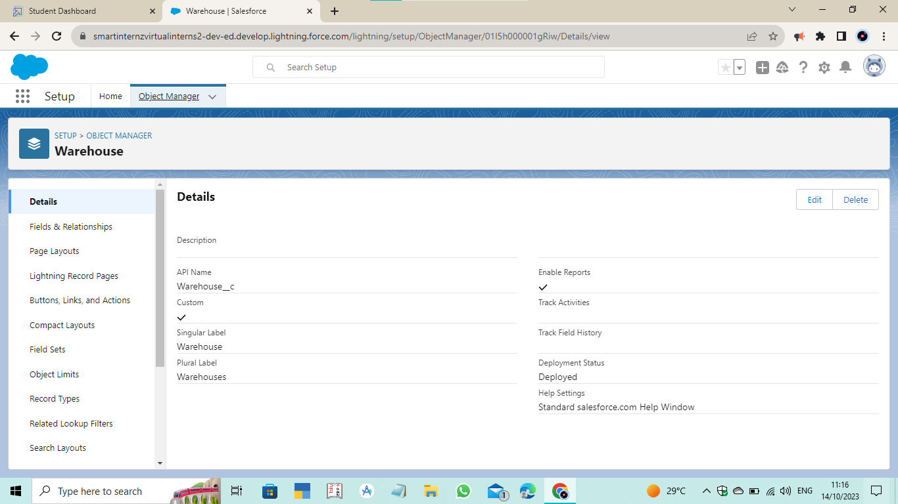

1. **Sales Order Object**

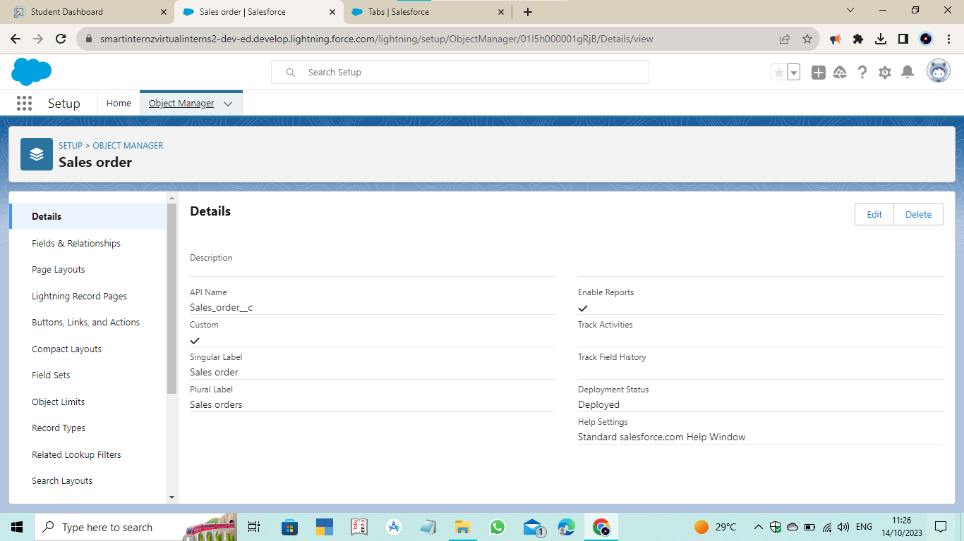

1. **Dispatch/Tracking Object**

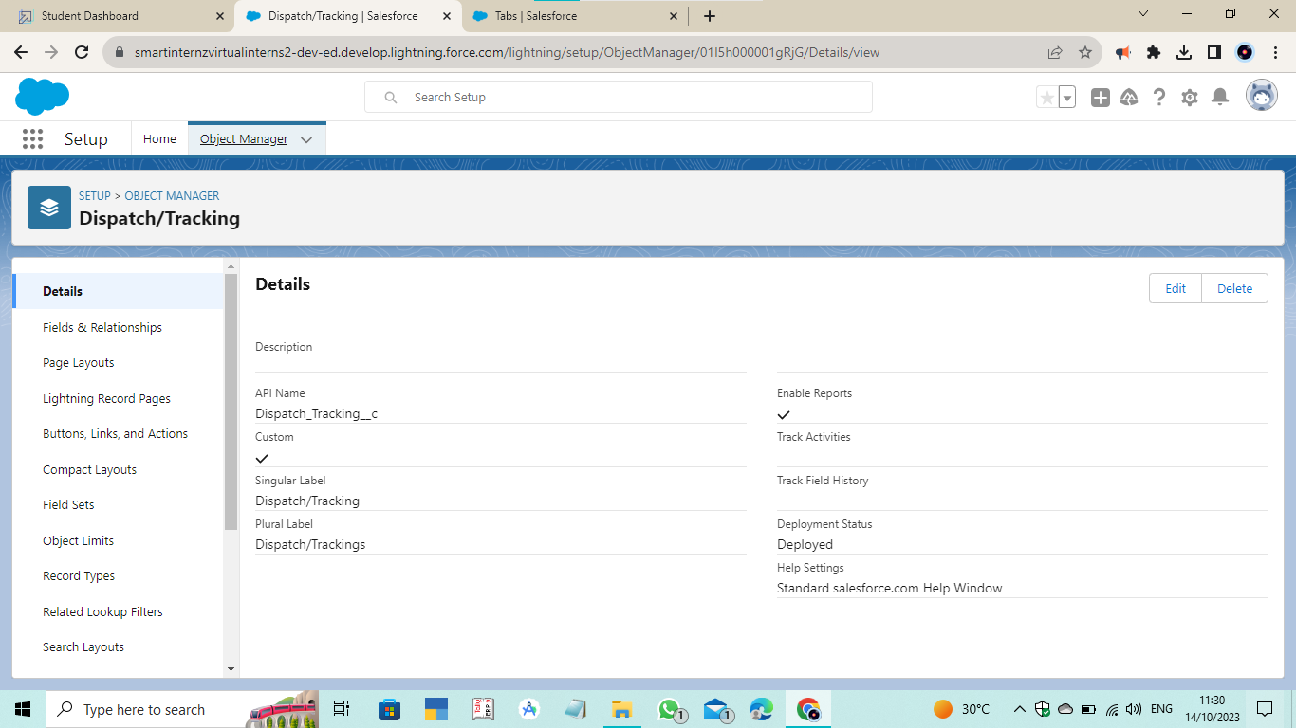

* **Tab**

1. Warehouse Tab
2. Sales Order Tab
3. Dispatch/Tracking Tab
4. **Warehouse Tab**

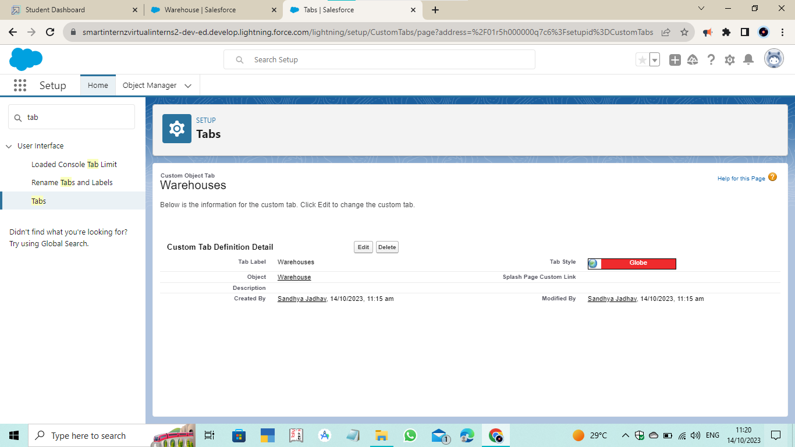

1. **Sales Order Tab**

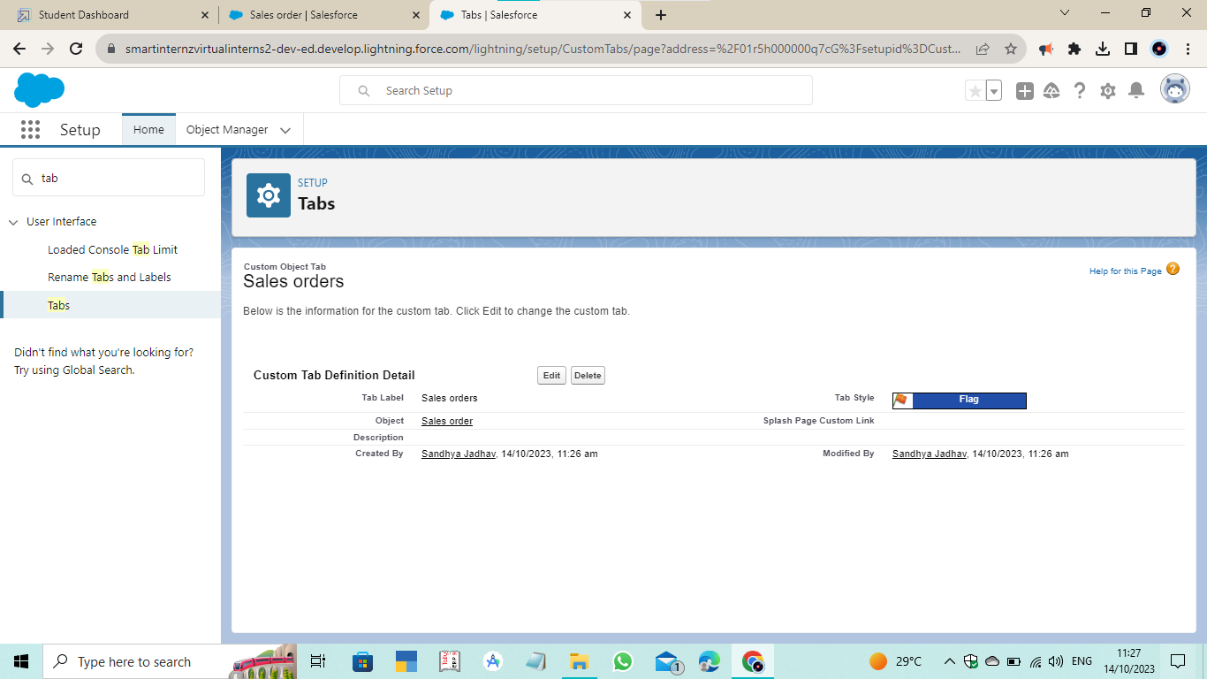

1. **Dispatch/Tracking Tab**

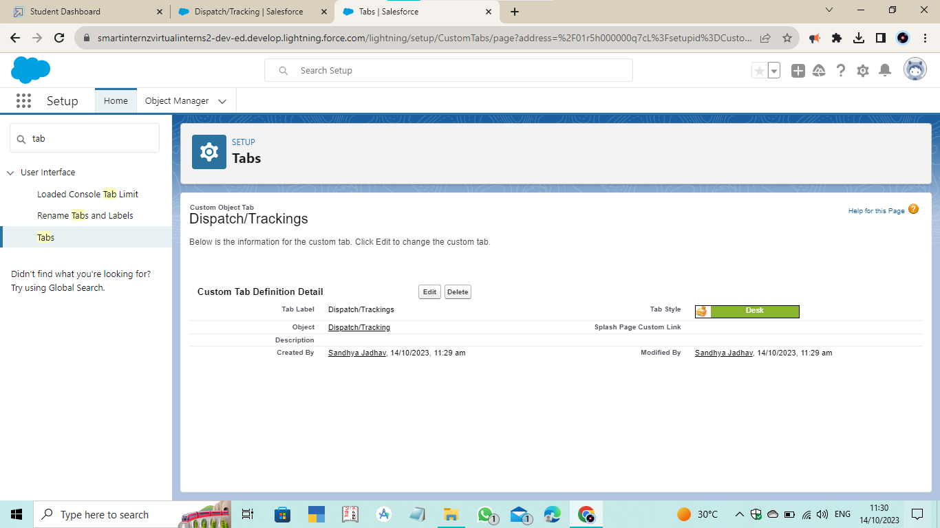

* **Created Lightning App of Sales App**

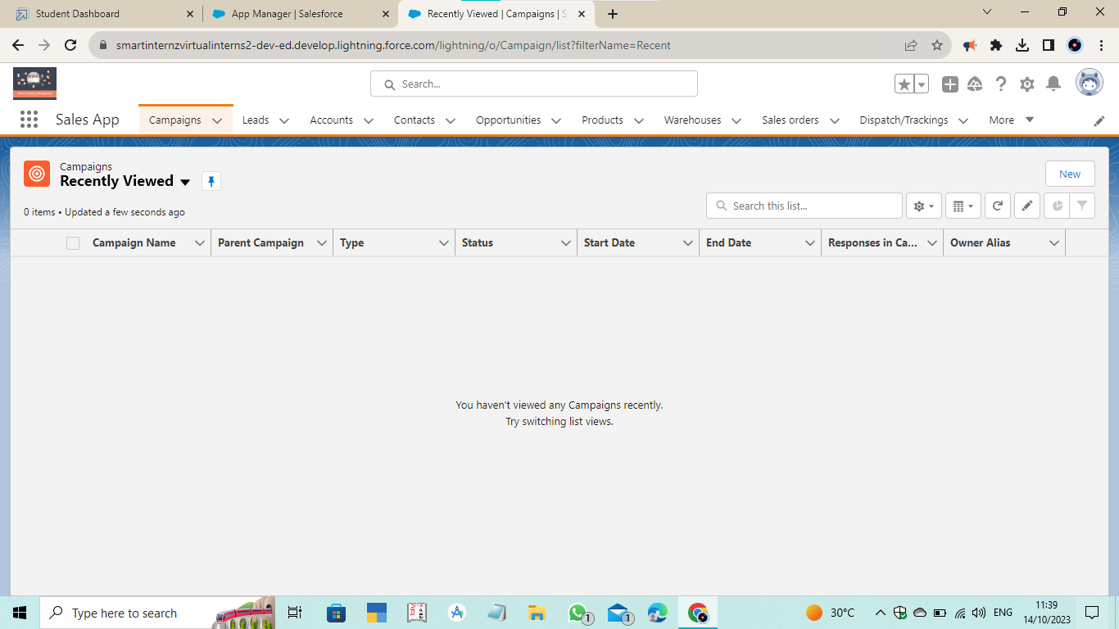

* **Fields and Relationships**

1. **Created Fields on Warehouse Object**

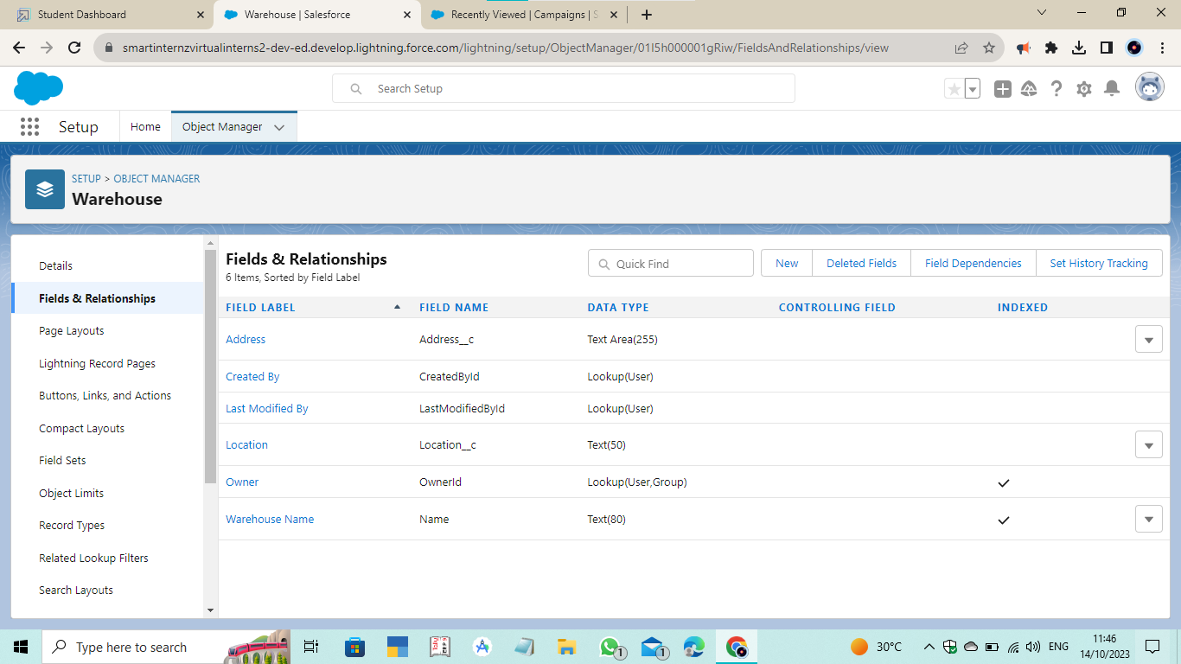

1. **Created Fields on Sales Order Object**

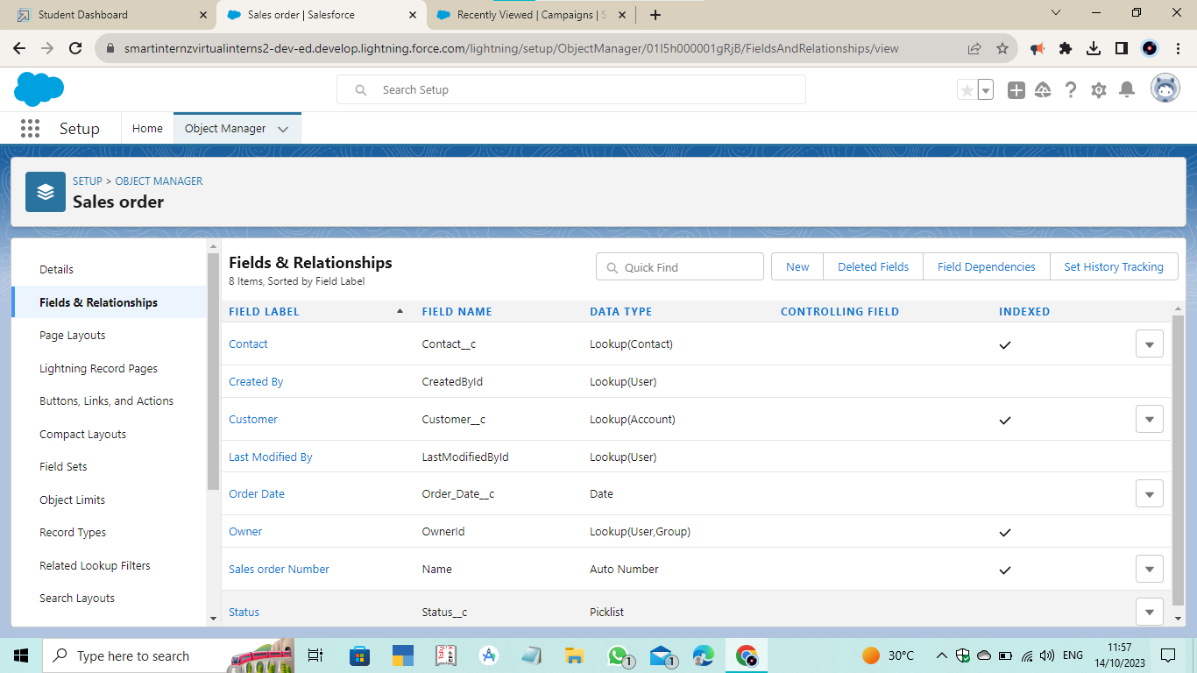

1. **Created Fields on Dispatch/Tracking Object**

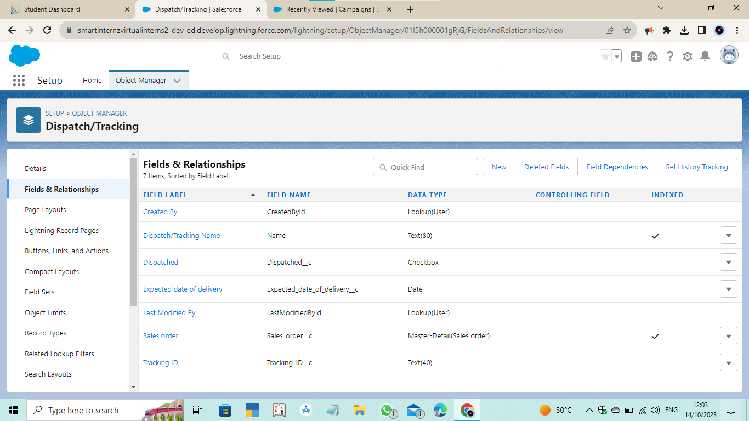

1. **Created Fields on Contact Object**

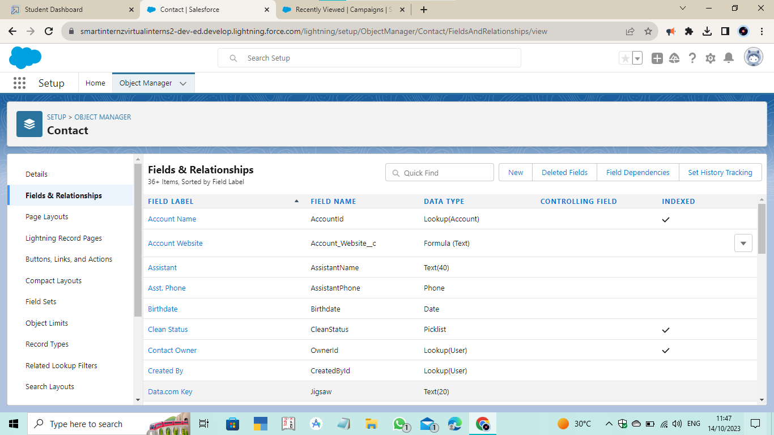

* **User**

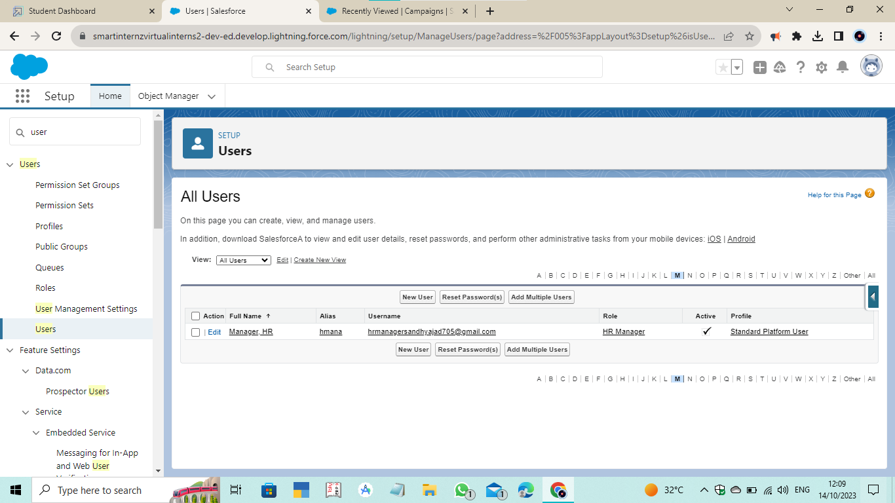

* **Validation Rule**

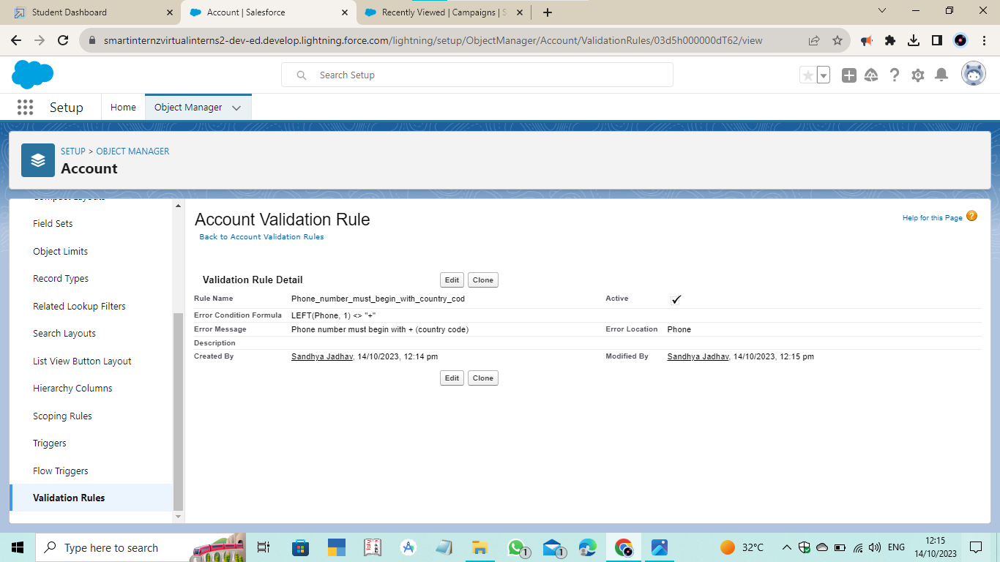

* **User Adoption**

1. **Created Record on Sales Order Object**

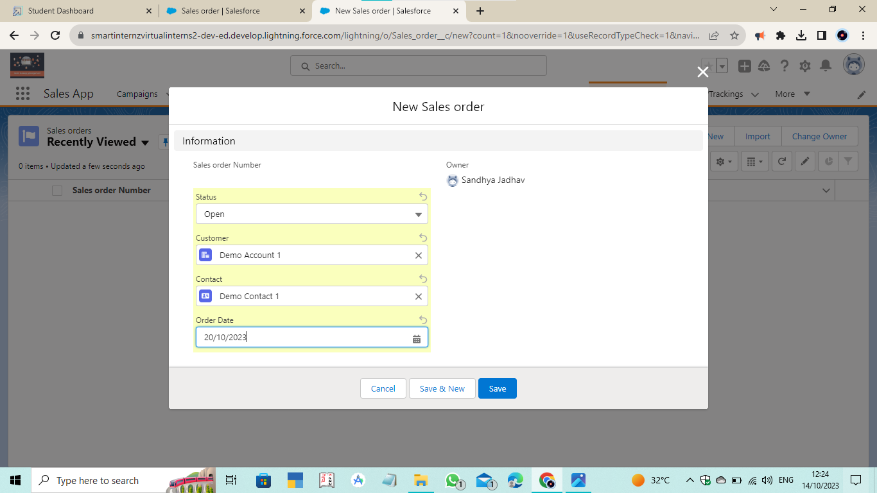

1. **Viewed Record on Sales Order Object**

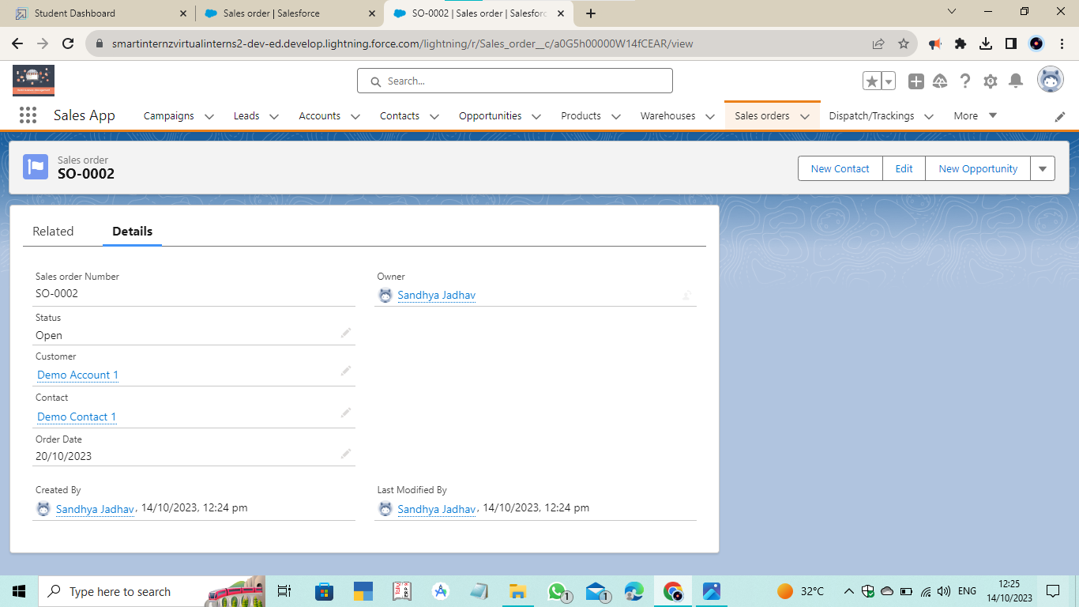

1. **Deleted Record on Sales Order Object**

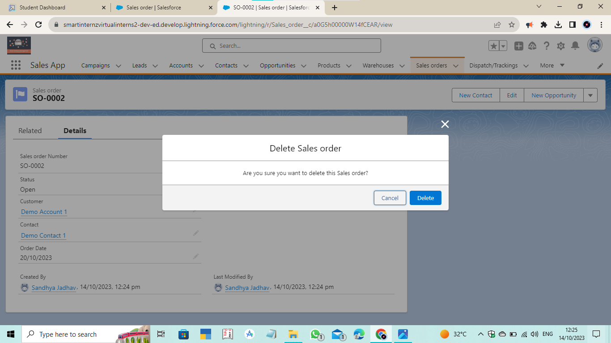

* **Report**

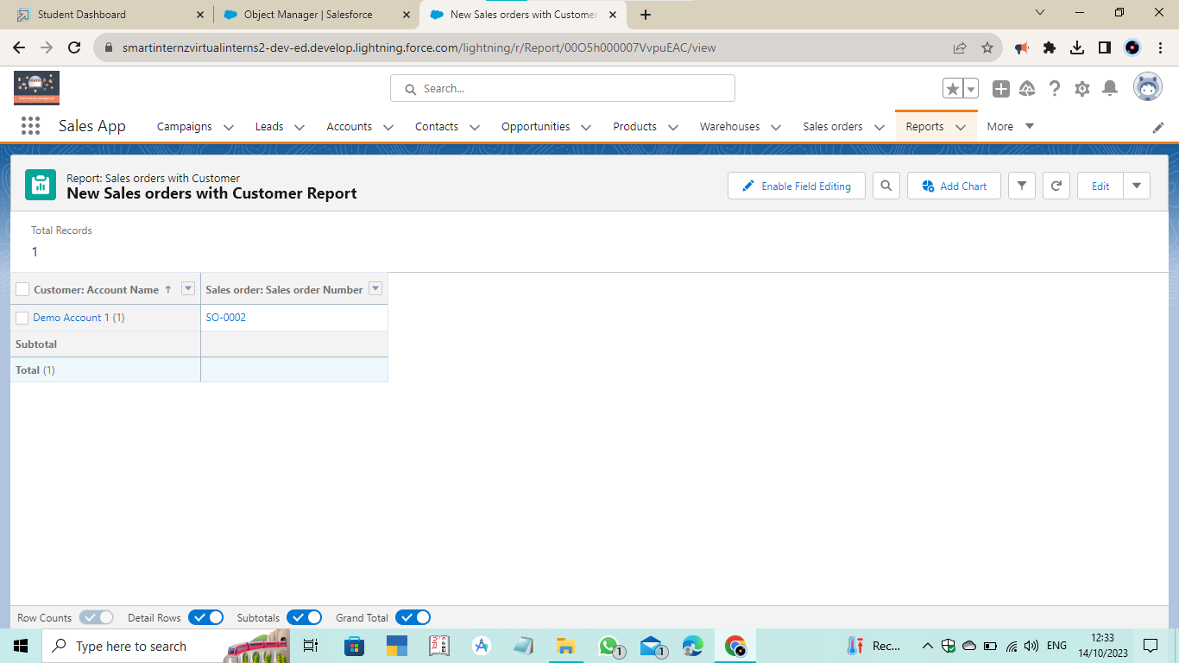

* **Dashboard**

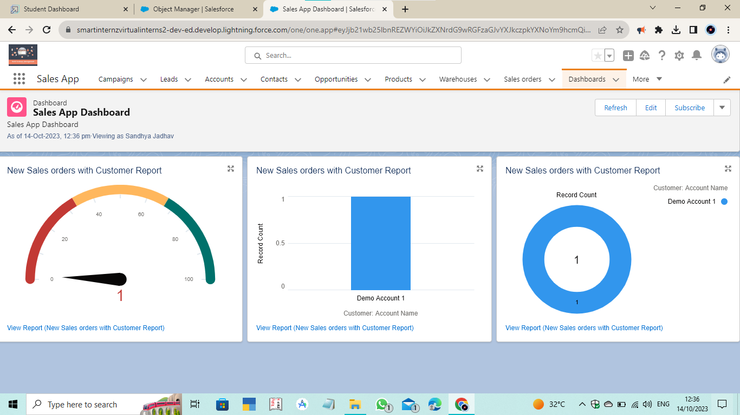

* **Flow**

1. **Created Screen Flow Get Contact and Account**

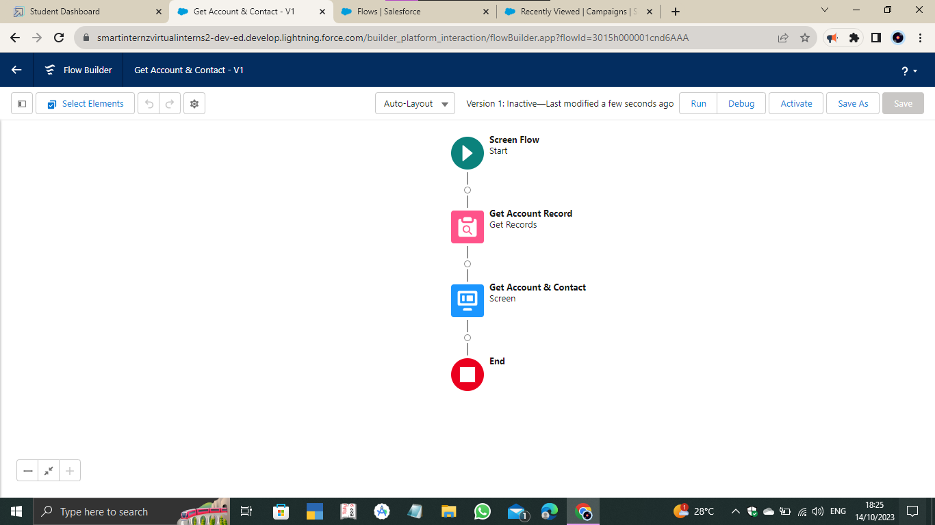

1. **Created Lightning Home Page Account and Contact**

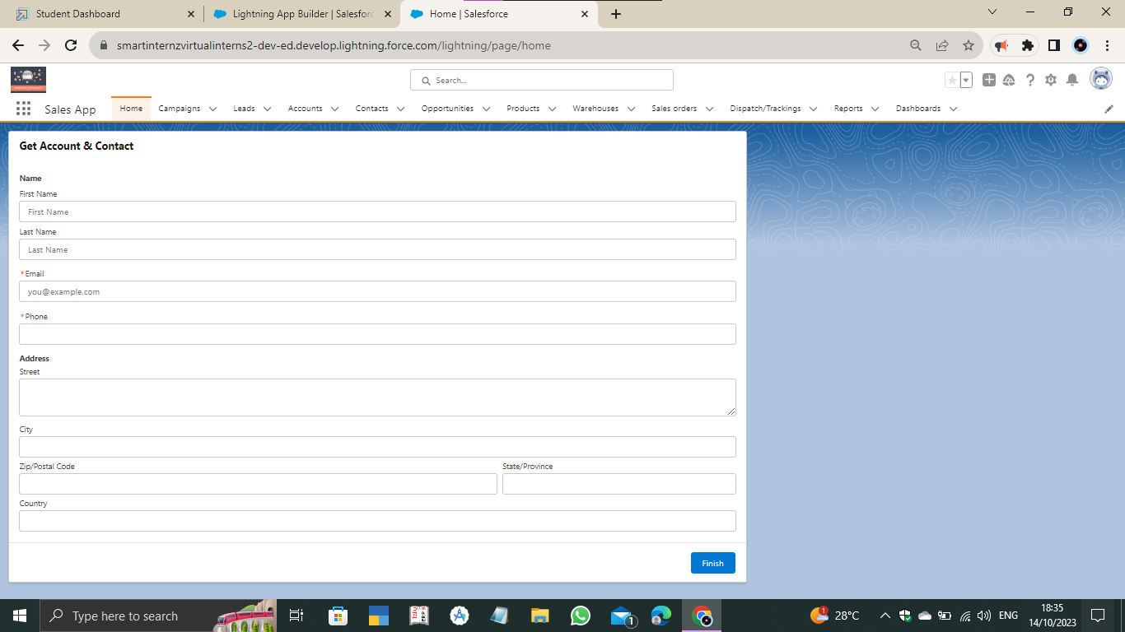

1. **Created Email and Order Confirmation fields on Sales Order object for sending email alert to customer**

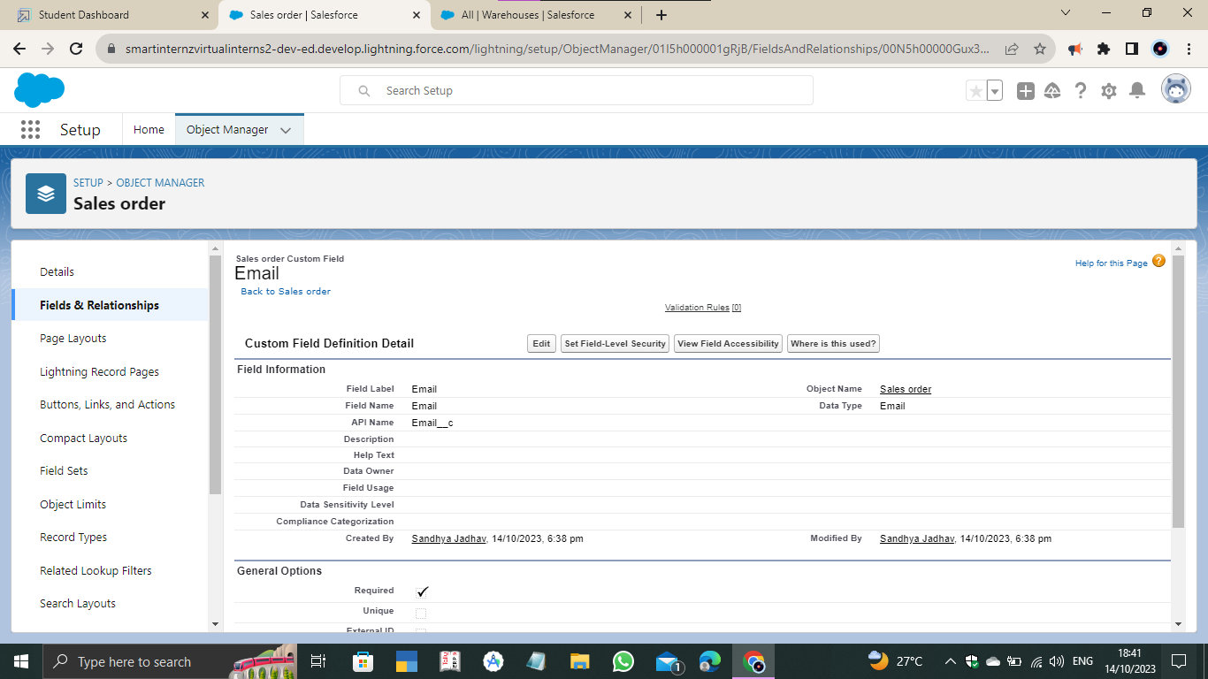

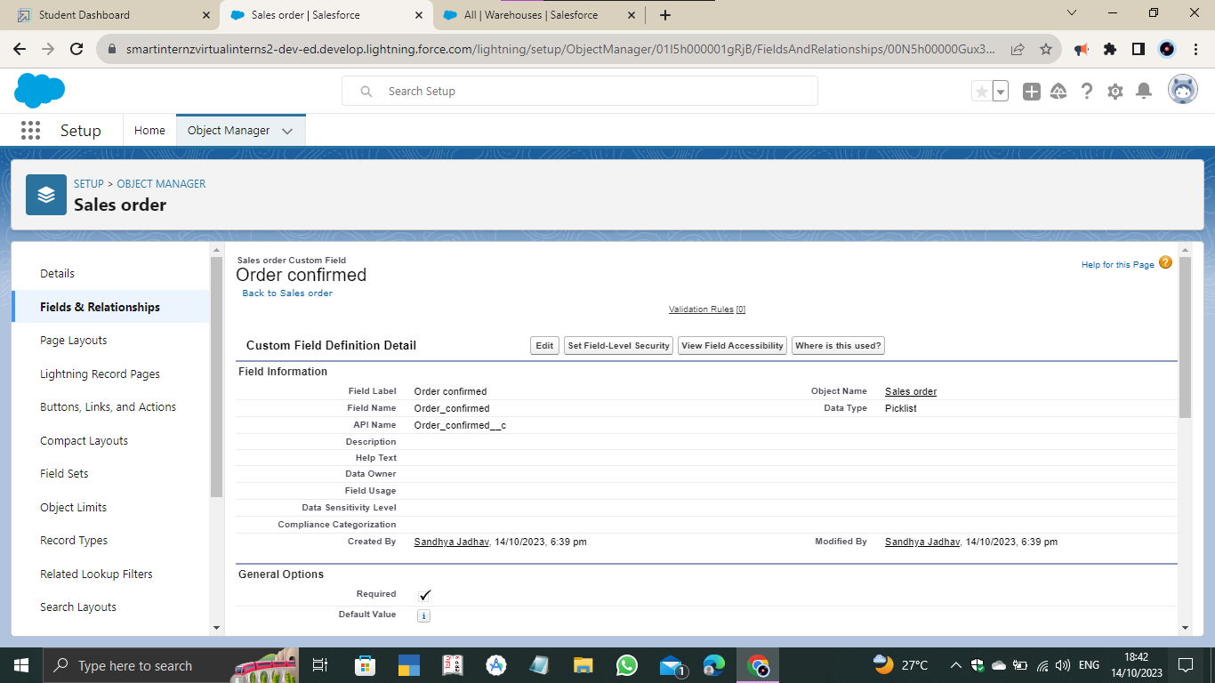

1. **Created Record Triggered Flow Email to Customer**

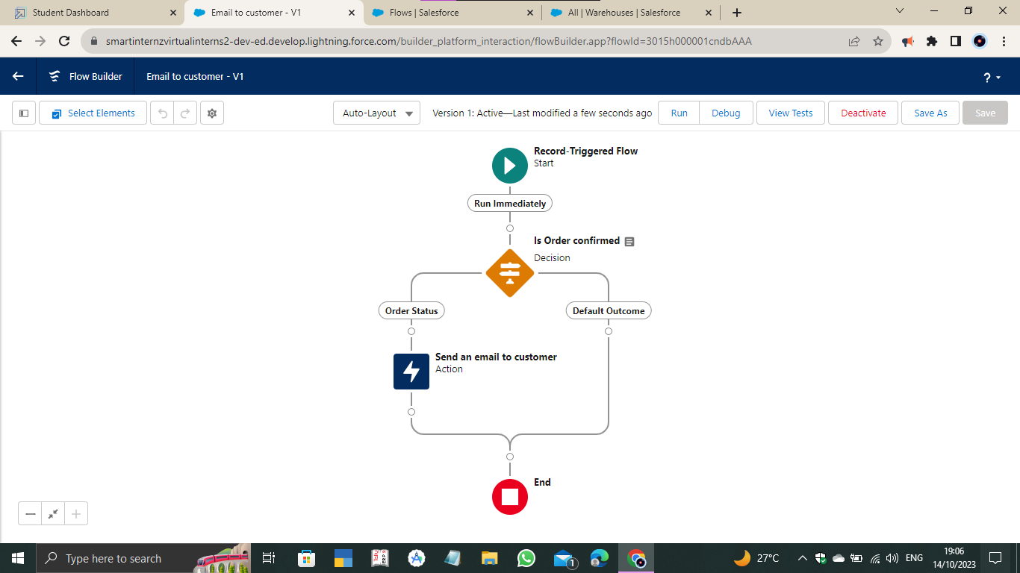

* **Trigger**

1. **Apex Class**

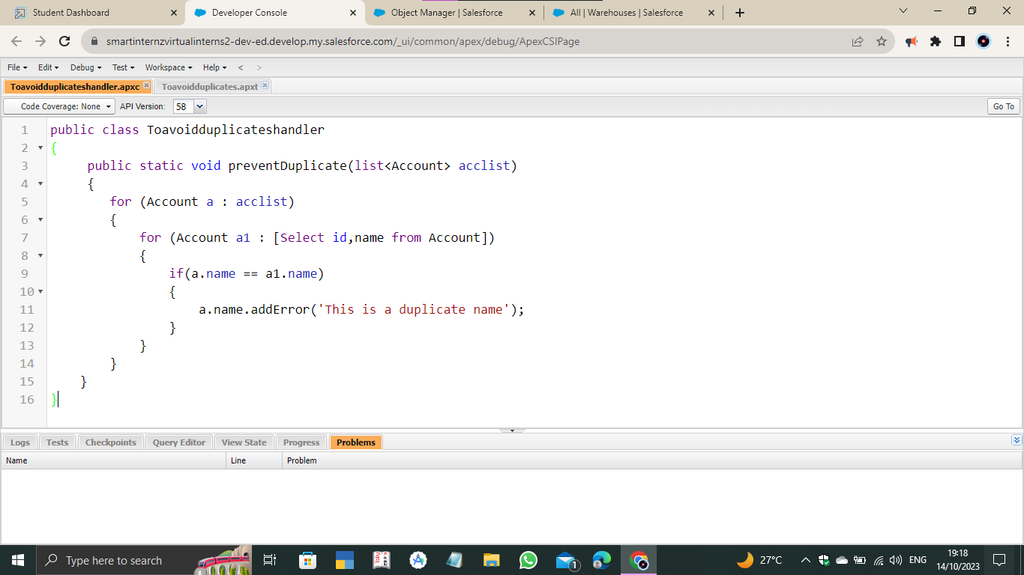

1. **Apex Trigger**

